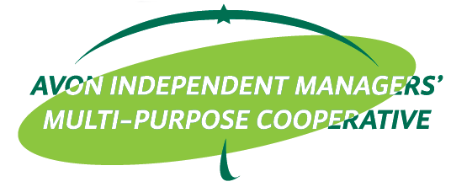
DEED OF AFFIRMATION AND ACKNOWLEDGMENT
(For Other Source of Income)

I, _____________________________________, Filipino, _______ years of age, (husband, wife, son, daughter) of ____________________________ (AIM-MPC Member) and resident of __________________________________________________________, declare the following:

- I personally know MR./MRS. ______________________ being my _____________, now ___________ years of age and residing at ________________________________________ ______________________;

- I further personally know that she has availed of loans with the Avon Independent Managers’ Multi-Purpose Cooperative (AIM-MPC) with business address at #884 Samat St., Brgy. Highway Hills, Mandaluyong City;

- I have been informed that my aforesaid ___________________ (relationship) 65% Avon Service Fee is not sufficient to qualify for the renewal of her __________________ loan;

- I am allowing him/her to use may pay slip, allotment, salary, commission, (others) pls. specify _______________________________ for the purpose of facilitating approval and release of the aforesaid loans;

- I hereby bind myself jointly to answer and/or deliver any and all liabilities, commitments and undertakings assumed by my _______________ (relationship) as member-borrower in the aforesaid loans with AIM-MPC in the event of her failure to do so.

- I affirm that I have read all the terms and conditions of his/her loans; that I understood the same; and that I voluntarily bind myself to the fulfillment of the terms, commitments, and undertakings in behalf of my _________________ in case of her inability to do so.

- I am executing this Deed in all good faith to attest to the truth of the facts above-stated to support the processing, approval and release of the subject loans.

IN WITNESS WHEREOF, I have hereunto affixed my signature this ____ day of __________________20_____ in Mandaluyong City, Philippines.

________________________________
Signature over printed name
Acknowledging Party
Government Issued I.D. (validity)

